User Manual

Home Tab

Profile Info

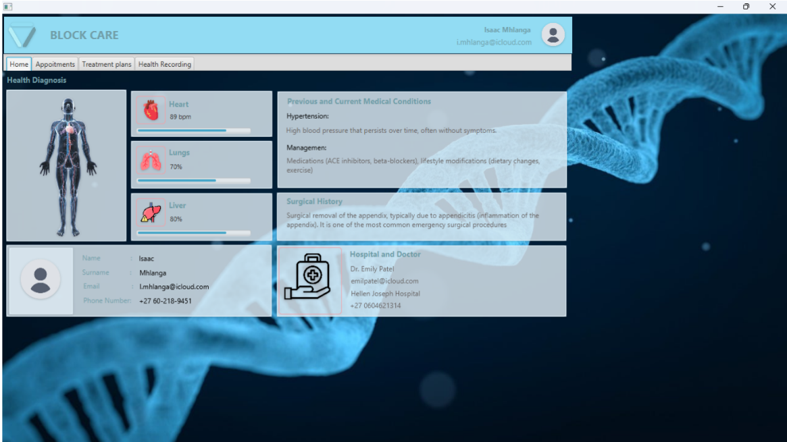

Medical History

User Info

Heart, Lungs, and liver conditions

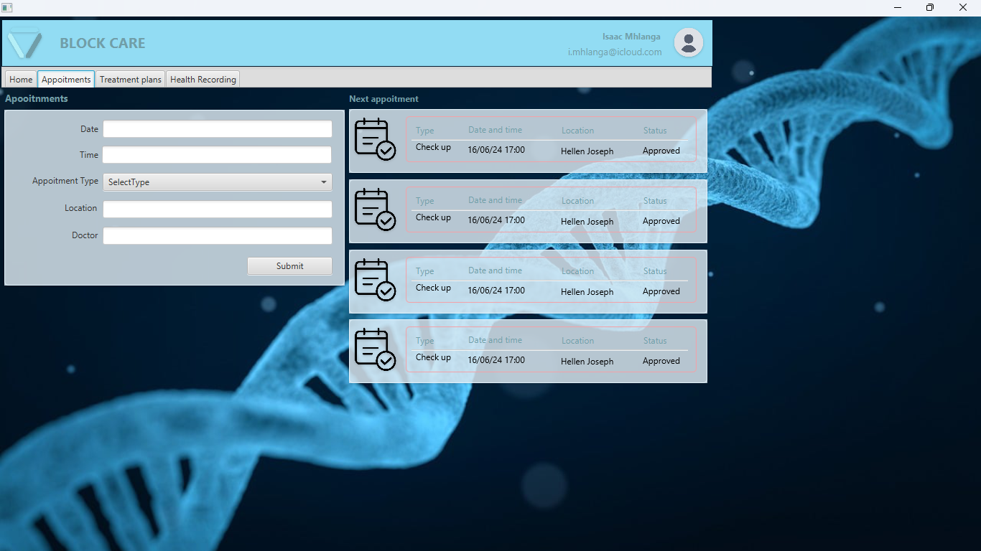

Appointments Form

Upcoming appointments

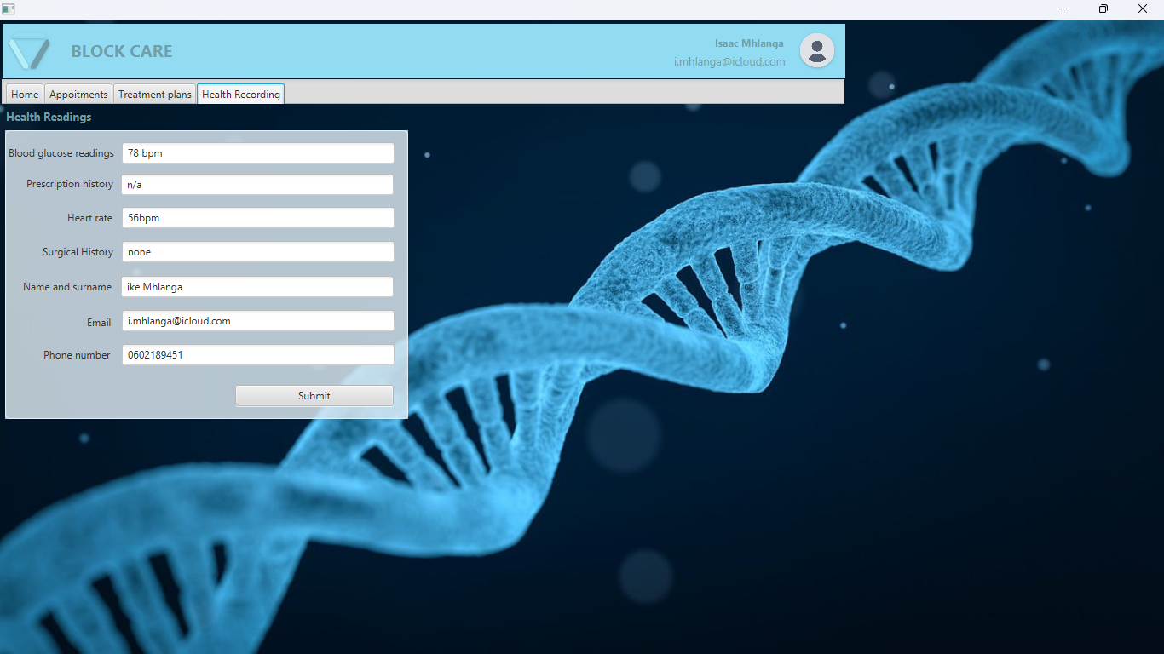

Heath Recording form

Treatments Plan

